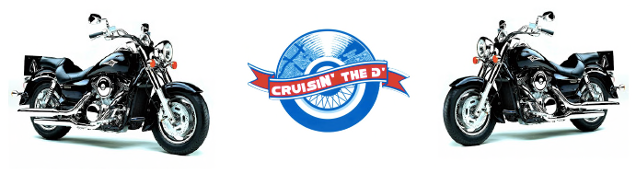

3rd Annual CruisIN’ The D’TM Registration Form
Biker’s Cruise with a Cause
A Multi-day Event Aug. 18th & 21st 2016
Rain or Shine
Biker Kick off Cruise: Thursday, Aug 18th, 2016 Palmer Park to Belle Isle
7/25 7/26 8/18 Concours
Pre-Registration $15 ___ Registration $20___ Onsite $25___ Competition $5___
(Includes Belle Isle Park (Includes Belle Isle (Biker has to (Separate fee
pass & complimentary Park pass) buy Belle Isle if biker wishes
t-shirt, while they last) Park pass) to enter)
Fallen Biker Close out Cruise: Sunday, Aug 21st, 2016 Erma Henderson Park
7/25 7/26 T-Shirt $20___
Early Registration $5___ Registration $10___ Size: L___ XL___ 2XL___
Color: Black____
Total: ____________________ (non-refundable)
Kick off Cruise 8/18
*Procession line-up at 5 pm, kick off at 6:30 pm
Palmer Park (Woodward at 6 Mile) to Belle Isle Park (Shelter #9)
*Registration fee guarantees entry to post-cruise Twilight Cookout
“RIDING FOR CHARITY” National Kickoff with Indiana’s Autism Speaks
CRUISE FOR A CAUSE. CRUISE IN BENEFIT OF AUTISM & VETERANS

Close Out Cruise 8/21
*Bikers rally at Erma Henderson Park at 3 pm and depart to American Bistro at 4:30 pm
*Closing Celebration from 4 pm - 8pm at 1917 American Bistro
1917 American Bistro @ 19416 Livernois Detroit 48221

For more information visit us at CruisinTheD.com or facebook.com/CruisINtheD

Mail this form and checks made payable to CruisIN’ The D’ to: 1201 Bagley Ave Detroit, MI 48226

Name_______________________________________________
Full Address:__________________________________________________________________
Phone:__________________________________________________
Email:___________________________________________________
Make:________________________________ Model:__________________________________
Year:_________________________________ Color:___________________________________
Clubs or Groups Welcomed! Name of Club/Group (if applicable):______________________________

I, the undersigned, hereby agrees to indemnify and hold harmless CruisIN’ The DTM and all its affiliates from any and all liability arising out of my participation in the CruisIN’ The DTM cruise/car show including but not limited to injury or damage to any person or property. I have read and understand the above and willingly set forth my signature below.

Authorized Signature_______________________________________________ Date___________________
Contact CruisIN’ The D’ at 313.961.3580 or 313.671.5423 – FAX 313.961.3582
REGISTER AT ONE OF OUR HUB SITES: 1917 AMERICAN BISTRO (19416 LIVERNOIS) or MO’ BETTER BLUES (546 LARNED)

