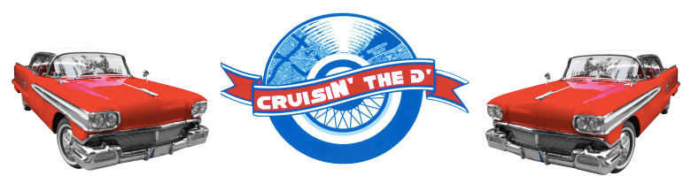
3rd Annual CruisIN’ The D’TM
Car Registration Form
Palmer Park Woodward Ave at 6 Mile
A Multi-day Event Aug. 20th-21st, 2016
Rain or Shine
Saturday Aug. 20th, 2016
CruisIN’ The D’TM 2016 Car Showcase/Cruise | CruisIN’ The D’TM 2016 Competition  (Includes official CruisIN’ The D’ T-Shirt)
Pre-registration $15___ On site $20___ T-shirt $20___  Showcase Woodward Grass Parking $25____  Showcase Lot Parking $20_____ | $40_____
T-shirt size: L___ XL___ 2X___ | T-shirt size: L___ XL___ 2X___
Total: _____________________ (non-refundable)
CRUISE FOR A CAUSE. CRUISE IN BENEFIT OF AUTISM & VETERANS
*Pre-registration fee guarantees you a spot for the whole day
*Cars parked as early as 8 am & Super Roll Cruise from Ford Piquette Avenue Plant at 10 am
*Grand Finale/Awards Ceremony starts at 5 pm
*Cruise Procession begins at 6 pm doing “Detroit Loop”

Winning cars will be featured Sunday, August 21st at the African World Festival
10 am – 2 pm at the Charles H. Wright Museum!

Close out dining Sunday, August 21st at 1917 American Bistro 19416 Livernois 5 pm – 9 pm

For more information visit us at facebook.com/CruisINtheD

Mail this form and checks made payable to CruisIN’ The D’ to: 1201 Bagley Ave Detroit, Mi 48226

Name_______________________________________________
Full Address:__________________________________________________________________
Phone:______________________________ Email:___________________________________________________
Car Make:___________________________ Model:__________________________________
Year:_________________________________ Color:___________________________________
Clubs or Groups Welcomed! Name of Club/Group (if applicable):______________________________

I, the undersigned, hereby agrees to indemnify and hold harmless CruisIN’ The DTM and all its affiliates from any and all liability arising out of my participation in the CruisIN’ The DTM cruise/car show including but not limited to injury or damage to any person or property. I have read and understand the above and willingly set forth my signature below.

Authorized Signature_______________________________________________ Date___________________
Contact CruisIN’ The D’ at 313.961.3580 or 313.671.5423 – FAX 313.961.3582

REGISTER AT ONE OF OUR HUB SITES: 1917 AMERICAN BISTRO (19416 LIVERNOIS) or MO’ BETTER BLUES (546 LARNED)

